HOUSEHOLD VEHICLE OWNERSHIP AND USE IN SHEFFIELD MIDDLE SUPER OUTPUT AREAS: DOES RESIDENTIAL DENSITY REALLY MATTER AND HOW MUCH?

BY

MARVIS ESIVUE

STUDENT ID: 32048079

- INTRODUCTION-----------------------------------------------------------------------------------------3
  - BACKGROUND OF THE STUDY------------------------------------------------------------------------3
  - AIM AND OBJECTIVES----------------------------------------------------------------------------------4
  - JUSTIFYING THE STUDY--------------------------------------------------------------------------------4
  - STUDY AREA----------------------------------------------------------------------------------------------5
- METHODOLOGY-----------------------------------------------------------------------------------------6
- RESULTS---------------------------------------------------------------------------------------------------6
3.1 DISTRIBUTION OF HOUSEHOLD WITH ACCESS TO CARS OR VANS WITHIN SHEFFIELD MIDDLE SUPER OUTPUT AREAS---------------------------------------------------------------------------6
3.2 DISTRIBUTION OF HOUSEHOLD COMPOSITION WITHIN SHEFFIELD MIDDLE SUPER OUTPUT AREAS -----------------------------------------------------------------------------------------------8
3.3 COMPARING THE TOTAL HOUSEHOLDS WITH THE TOTAL NUMBER OF CARS OR VAN IN SHEFFIELD MIDDLE SUPER OUTPUT AREAS. -------------------------------------------------------9
3.4 DISTRIBUTION OF TOTAL POPULATION ACCESS TO CAR OR VAN IN SHEFFIELD MIDDLE SUPER OUTPUT AREAS------------------------------------------------------------------------------------10
3.5 RESIDENTIAL DENSITY AND THE RELATIONSHIP BETWEEN HOUSEHOLD VEHICLES OWNERSHIP AND USE IN SHEFFIELD-------------------------------------------------------------------11
- DISCUSSION---------------------------------------------------------------------------------------------12
4.1 LIMITATION OF THE STUDY--------------------------------------------------------------------------12
- SUMMARY----------------------------------------------------------------------------------------------12
- REFRENCES----------------------------------------------------------------------------------------------13
LIST OF FIGURES AND TABLES
FIGURE 1: A MAP SHOWING SHEFFIELD MIDDLE SUPER OUTPUT AREAS------------------------------------------------------------------------------------------------------------------------------------------------------6
FIGURE 2: SHOWING THE SUM OF ALL CARS OR VANS DISTRIBUTION WITHIN SHEFFIELD MIDDLE SUPER OUTPUT AREAS-------------------------------------------------------------------------------8
FIGURE 3: A MAP OF SHEFFIELD SHOWING THE TOTAL HOUSEHOLD COMPOSITION IN SHEFFIELD MIDDLE SUPER OUTPUT AREAS. ----------------------------------------------------------------9
FIGURE 4: A MAP OF SHEFFIELD MIDDLE SUPER OUTPUT AREAS SHOWING THE PERCENTAGE OF POPULATION WITH ACCESS TO CAR OR VAN. ----------------------==-------------------------------11

TABLE 1: A graphical representation showing how car or van ownership varies in Sheffield---------------------------------------------------------------------------------------------------------------------------12

1. Introduction
1.1 Background of the study
According to UN world urbanization prospects, Sheffield’s 2023 population is said to be a total of 808,867, which have seen Sheffield have an increased annual growth rate of 0.6% from the year 1950. A very important question to ask is if population density influences the number of vehicle movements in Sheffield or if the increase in vehicle ownership has affected areas in Sheffield. There is no doubt that the number of vehicle movements in a city can play a major role in that city, whether good or bad. According to data from the 1990 nationwide personal Transportation Survey (NPTS), A 10% rise in household income results in a 3% rise in car travel. (Paul. S, et al 2019a). The connection between the dwellings per hectare and vehicle travel pattern has recently attracted considerable attention due to concerns over the effects of rising vehicle usage on air quality, accidents, traffic and quality of life. (Kai. Z, et al 2013). This report examines if household and residential density affects the amount of household vehicle use in Sheffield and it also examines if the effects is big enough to cause changes in air quality, traffic, quality of life. Urban population density is one of the most identifiable importance of a city and it is usually a general determinant of urban form. population density that is high is related with good economies, urban amenities and good public transport while a lower population density is related with bad pollution levels, damage of the environment and a great margin between the rich and the poor.( Ciccone and Hall, 1996; Glaeser et al., 2001, 2008; Rosenthal and Strange, 2004). Transportation is one of the biggest causes of carbon-dioxide emissions and authorities can have little or significant control on emissions caused by transportation. Cars can cause changes to cities organization. In research by (Jos. V, 2022) where he used a sample of 123 cities in 57 countries to explain that vehicle ownership can make the population density and employment rate reduce. Vehicles have made movement cheaper and faster, and this has made people live in more distant areas from their work than they did 50 or 100 years back (Victor. M, 2022). During the corona-virus pandemic, the number of cars on the highway reduced, but the road is already getting more congested. Car ownership rose to 14 percent in Sheffield around 2012-2022. A good number of cities are thinking about implementing clean air zones as a strategy to reduce private car ownership and improve the quality of air. This would mean that drivers whose vehicle cause more pollution while travelling through peculiar areas would be charged or fined. Dependency on vehicles is caused by poor transportation systems.

This report tends to examine household vehicle ownership, effects and the relationship of vehicle ownership and use with residential density in Sheffield Middle Super Output Areas.

1.2 AIM AND OBJECTIVES
AIM OF THE STUDY
The aim of the report is to examine if households and residential density affects the amount of household vehicles use in Sheffield. This report also examines the effect of household vehicle ownership and use in Sheffield.
OBJECTIVES OF THE STUDY
The objective of the study includes the following:
- Examine the distribution of household composition in Sheffield Middle Super Output Areas.
- Examine the distribution of the number of populations with access to cars or van in Sheffield Middle Super Output Areas.
- Examine the residential density and the relationship with household vehicle ownership and use in Sheffield Middle Super Output Areas.

1.3 JUSTIFYING THE STUDY
Since the beginning of the 20th century, a lot of people has had more access to private vehicles than they did in previous centuries due to industrialization and improvements in technology, (Jia. Y, 2020) This has made access to vehicles a lot easier. According to Wikipedia (2023) There is no doubt that the importance of cars on the societies cannot be over emphasized, but despite their importance, vehicles can have negative effects. The consequences of constant vehicle use in households has led to increase in traffic congestion, noise and air pollution, accidents, CO2 emissions and obesity. According to YorkshireLive (2021) “Trying to solve traffic problems in Sheffield is an uphill struggle and the endless hills in the city doesn’t make it any better”. According to research from the Sheffield city council, the biggest complaints after asking residents how to reduce traffic to make walking and cycling easy, was about double parking and pavement parking. However, one problem identified was the fact that most residents who lived on streets that are tightly packed owned a car and most wanted to park outside their houses. Traffic congestion is mostly caused by the rigorous use of private vehicles (Alberto. B, 2004). In many parts of the world today, traffic congestion has been on a steady rise, and it doesn’t look like stopping, this can lead to an undeniable threat to the quality of urban life. Traffic congestion occurs mostly when private vehicle is intensively used on roads. Yes, they have positive sides in terms of making mobility easy and provide a certain level of comfort and privacy, yet they are not the best means of transportation. In rush hour periods when different owners of a private vehicles are usually on the road, private car owners can cause as much as 11 times the congestion as a passenger inside a bus (Alberto. B, 2004). According to National Travel Survey (2021), There has been a significant rise in the part of households with access to cars since 1971. About 33 percent of households have 2 or more vehicles in 2021 compared to the 8 percent in 1971. The number of households without a car has decreased from 48 percent in 1971 to 22 percent in 2021.
1.4 STUDY AREA
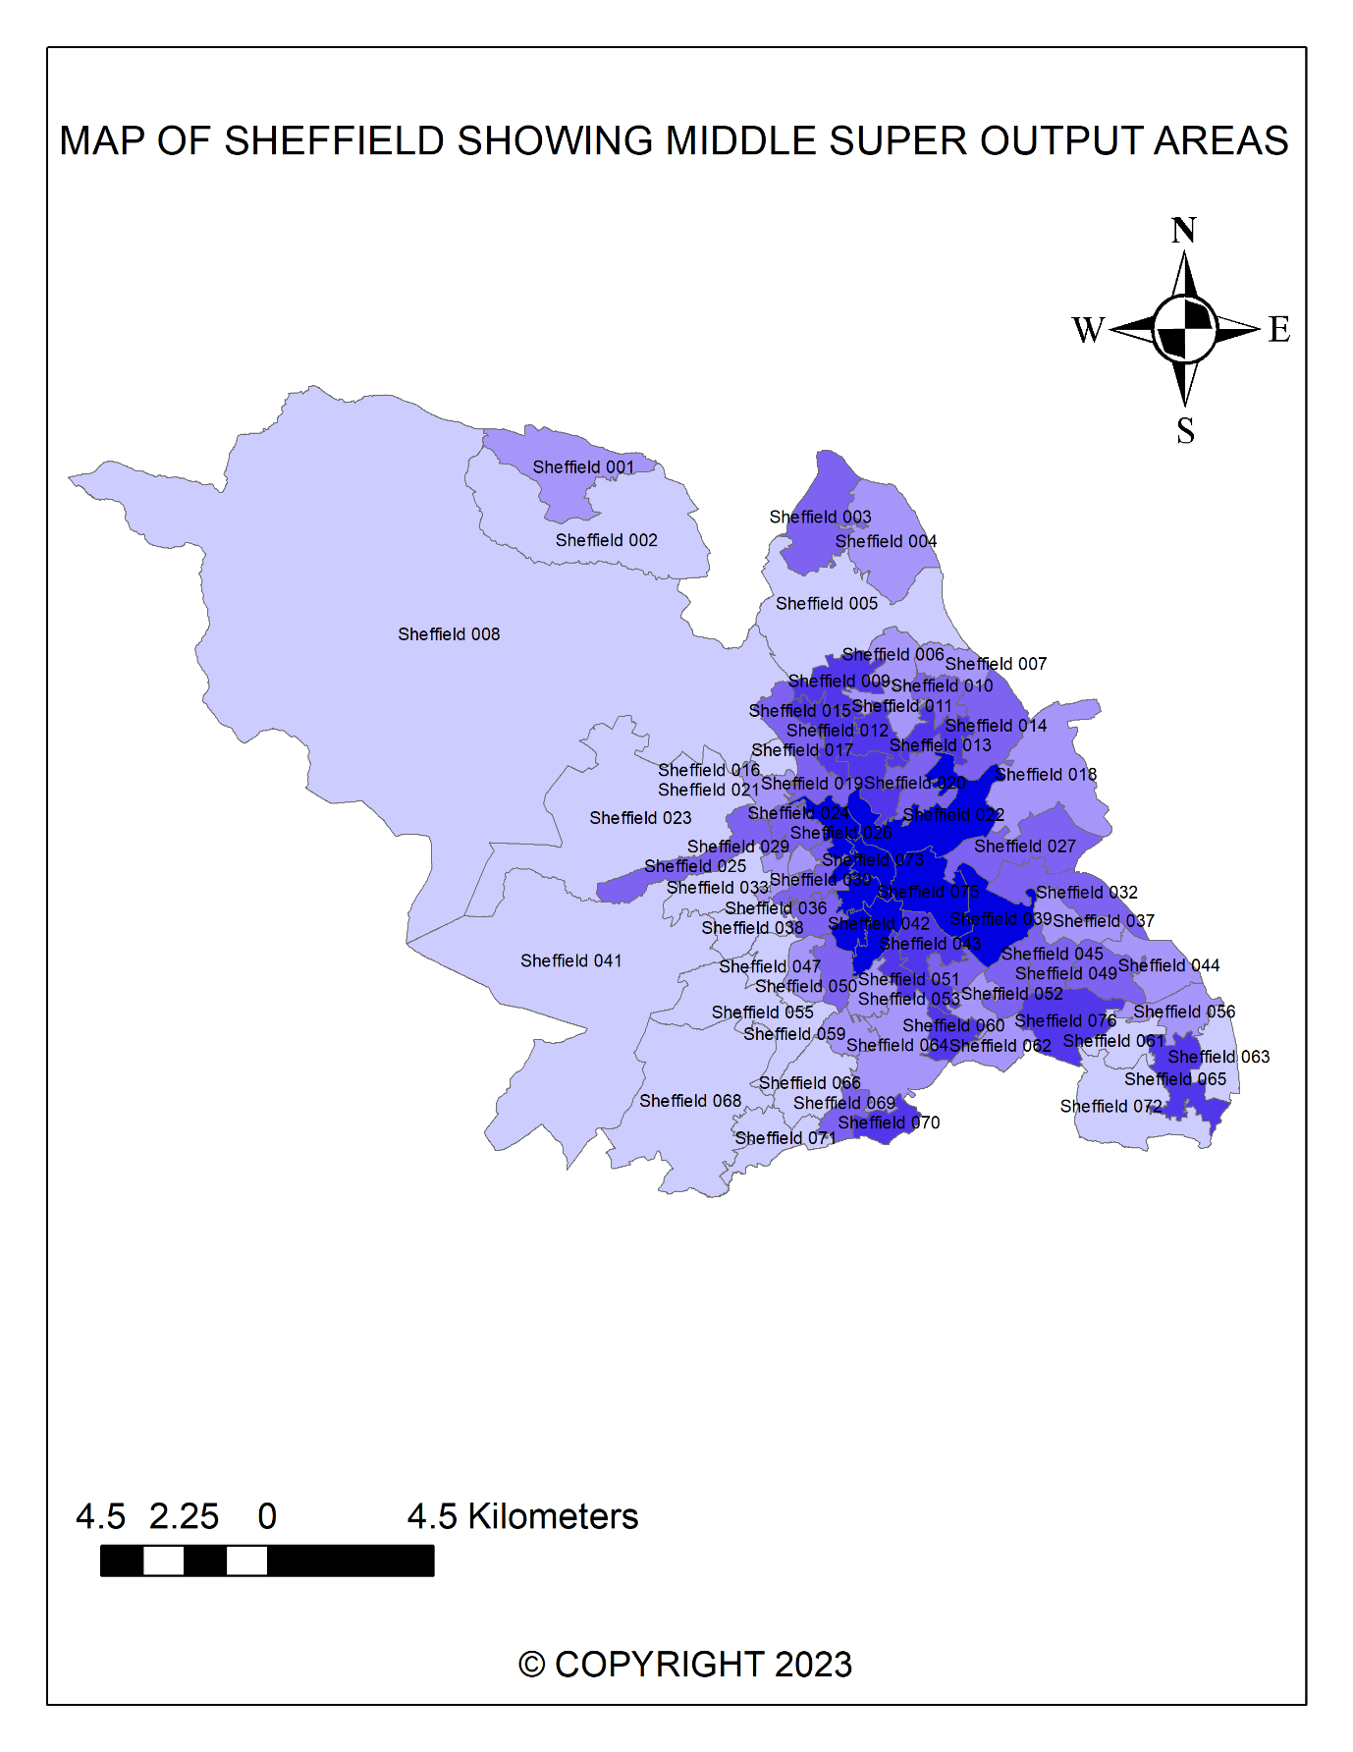
Figure 1: A MAP SHOWING SHEFFIELD WARDS
SOURCE: AUTHOR’S ANALYSIS (2023)

Sheffield is a city in South Yorkshire, England, Sheffield has the biggest settlement in South Yorkshire. A third of Sheffield lies within the Peak District National Park while 61% of the city total area is green space. Sheffield is 53 kilometers north of Nottingham, 47 kilometers south of Leeds and 51 kilometers east of Manchester.

2. METHODOLOGY
The data used for this study comprises of data collected from (Office for National Statistics et al, 2011). The information on number of cars and vans, household compositions, wards based on Sheffield were collected. The variables collected from cars and van data from infuse includes sum of all cars and van in Sheffield, number of households with 1 car or vans in Sheffield, number of households with no car or van. Percentage of the total number of households, 1 car or vans, sum of all cars or van, households with no car or vans were all calculated.

3. RESULT
3.1 Distribution of Household with Access to Cars or Vans Within Sheffield Middle Super Output Areas
The geographical distribution of the total number of cars or van in Sheffield is shown below in Figure 2. And from the Figure below you can see that the number of cars and vans are predominantly high in a lot of areas in Sheffield, even the central area of the map shows a lot of clustering of vehicles, with 1,325 to 2,372 vehicles as the lowest in a particular area in Sheffield and 5,513 to 6,559 being the highest vehicles in a particular area of Sheffield. Other areas still have high number of cars or van, with some areas have as high as 3,420 to 4,465 while some have 4,466 to 5512. The total amount of the number of cars or vans is included in the map in each area for easy representation of the data.

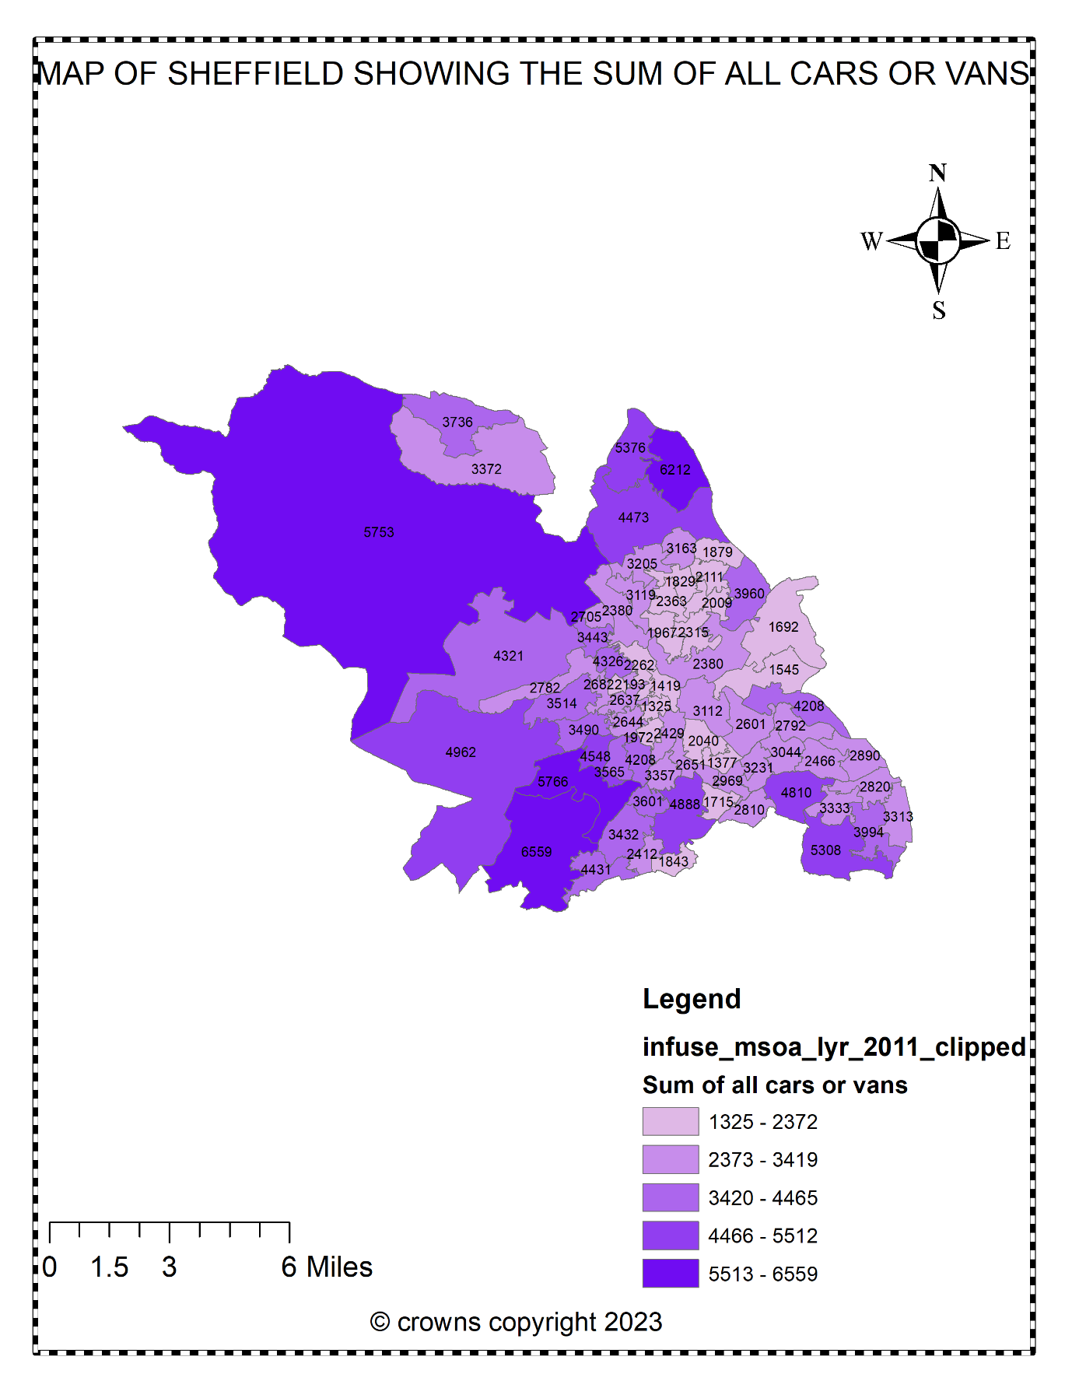
Figure 2: Showing the sum of all cars or vans distribution within Sheffield Middle Super Output Areas.
Source: Author’s Analysis (2023)

3.2 Distribution of Household Composition within Sheffield Middle Super Output Areas
The geographical distribution of the total number of households in Sheffield is shown below in Figure 3. The distribution of household composition in Sheffield is studied based on the Middle Super Output Areas, and from the Figure below you can see the number of households in each area.
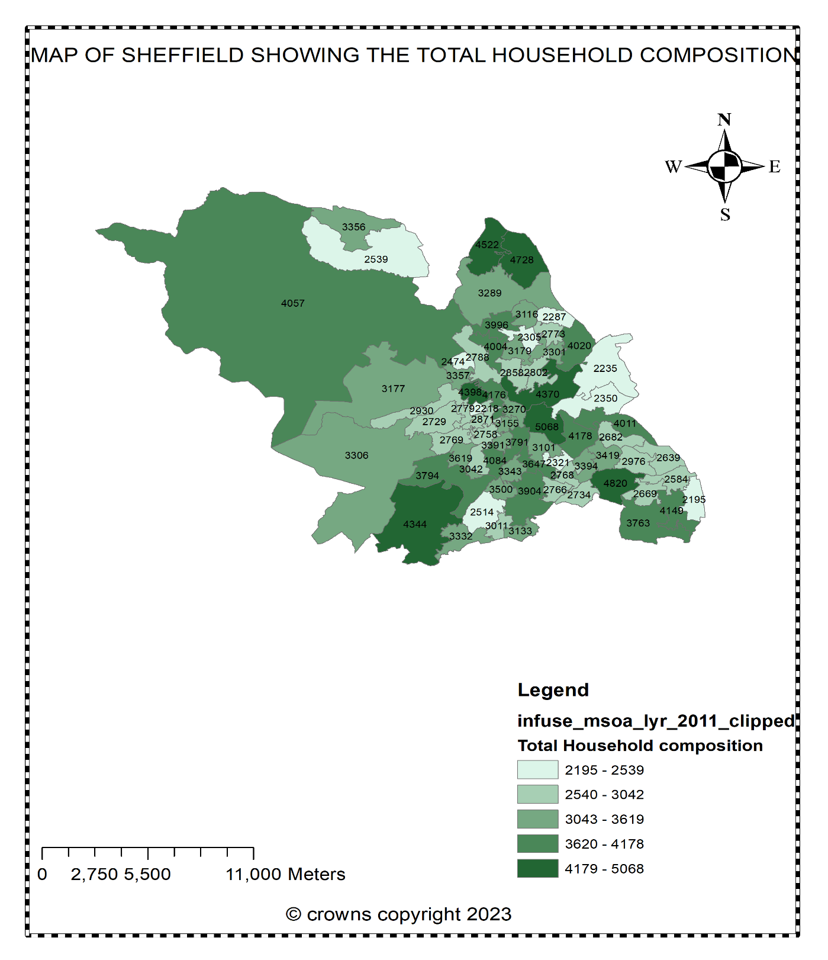
Figure 3: A Map of Sheffield showing the Total Household Composition in Sheffield Middle Super Output Areas.
SOURCE: Author’s Analysis (2023)

3.3 COMPARING THE TOTAL HOUSEHOLDS WITH THE TOTAL NUMBER OF CARS OR VAN IN SHEFFIELD MIDDLE SUPER OUTPUT AREAS.
According to (Steve. R, 2022), Household in cities are at a great risk of being congested with cars as the ownership of cars increases faster than the growth of population. The number of vehicles licensed to the private owners has skyrocketed greatly in Sheffield and other neighboring areas in the last ten years. When comparing Figure 2 and Figure 3 together, we can see that the number of vehicles (cars or vans) are more than the number of households in most of the middle super output areas, this alone creates a parking problem since most people intend to park right outside their apartments.

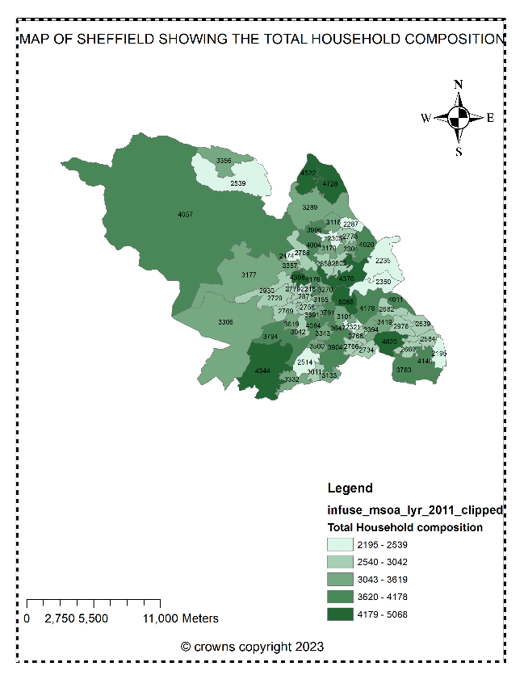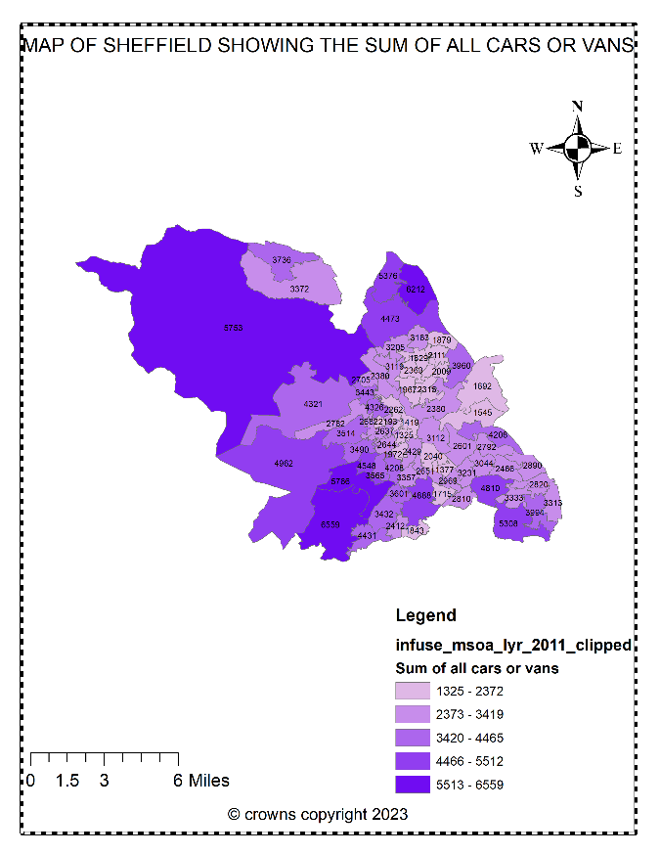
Figure 2 and figure 3: Showing the comparison between total households and total numbers of cars and vans in Sheffield Middle Super Output Areas.
SOURCE: AUTHOR’S ANALYSIS (2023)

3.4 Distribution of Total Population Access to car or van in Sheffield Middle Super Output Areas
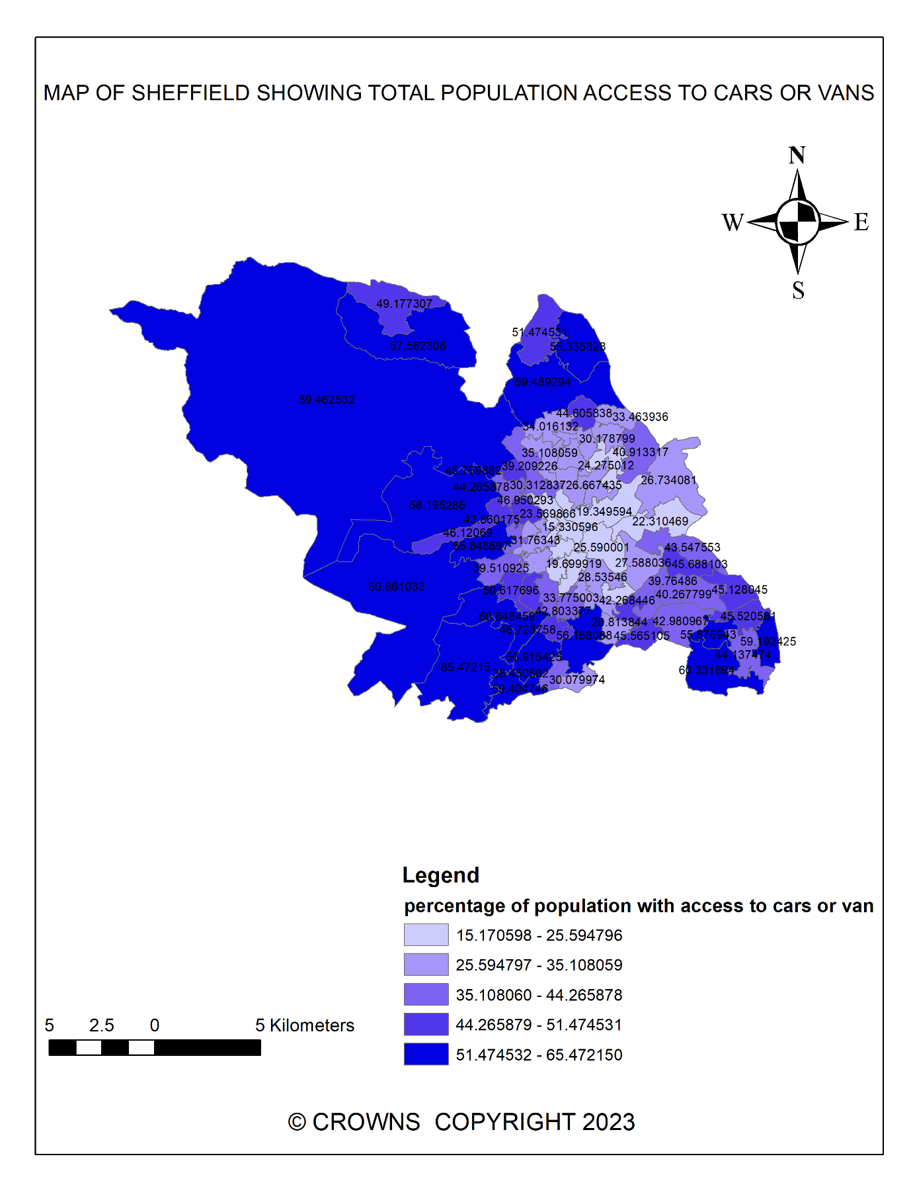
Figure 4: A map of Sheffield Middle Super Output Areas showing the percentage of Population with access to cars or vans.

SOURCE: AUTHOR’S ANALYSIS (2023)
In the map above (Figure 4), the lowest percentage with access to vehicle was 15.17 percent while the highest areas of population with access to vehicles was 65.4 percent. A lot of Sheffield population have access to vehicles.

A GRAPHICAL ILLUSTRATION OF HOW CAR OWNERSHIP DIFFERS BY EMPLOYMENT
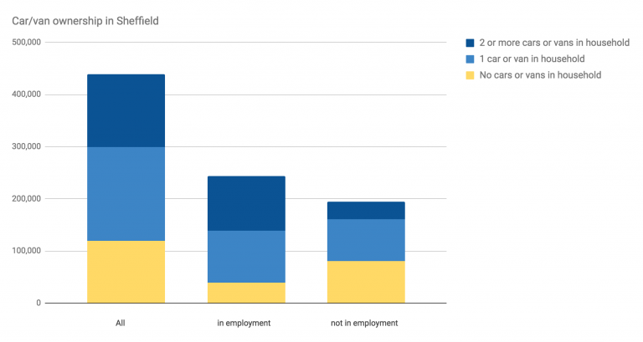
Figure 5: A graphical representation showing how car or van ownership varies in Sheffield.
SOURCE: 2011 CENSUS DATA

3.5 Residential density and the relationship between household vehicles ownership and use in Sheffield.
Today, more than ever, a lot of people do need a car to travel to their place of work and public transportation can be unreliable sometimes. One of the greatest statistical determinants of the number of cars and vans in an area is the household size in that area, household type, household income and the number of workers in that household. When there is a 1% increase in household income it can cause a 0.41 % rise in the number of cars and vans in households (Paul. S, 2019). The number of cars or vans in an area can affect the population density of that area, for instance, in places where a car is not expensive, there will be a higher number of car ownership, since the cars are not expensive it becomes attractive to commute longer distances. 1 addition of a car to 100 people is connected to a 7.2 percent reduction in urban density (Glaeser et all, 2004). This suggest that a place with reduced car ownership will have higher urban densities.
4. Discussion of the study
There is no doubt that the introduction of private vehicles in this modern century has been instrumental in the development of the world and vehicles play an important role in our world today. It has made mobility to different places easier and has also increased the standard of living. Over the last decade, privately owned vehicle was only available for a selected few as the price of owning a vehicle was very expensive. But due to advancement in technology and increase in car manufacturing companies, it led to a decrease in vehicle prices. The decrease in vehicle price meant that the number of people that will be able to afford it increased., this led to a surge in vehicle ownership.
As Sheffield population continues to increase, it is encountering the problem of larger numbers of vehicle ownership and use. This report examined the problems associated with household vehicles ownership and use in Sheffield and aimed to examine the negative effects of household ownership and use of private vehicles. The government need to look for ways to curtail this issue to further prevent it from getting worse.
4.1 Limitation of the study
Due to the limited data available for this research, one of the samples used for this study was based only on the number of cars and vans in Sheffield Middle Super Output Areas and as a result, the research was narrowed down to just cars and vans. The result of this study may not be applicable if we considered other types of vehicles such as bikes, trucks, motorcycles. Most of the data for the research was a 2011, the result could be different or slightly different if a more recent data was used.

5. Summary
This report summary shows that people in Household of places that have a higher residential density make lesser vehicle journey and travel lesser vehicle kilometer than those in lower residential density areas, Walking and transit trips occurs a lot in places with higher density.
People can try another alternative to private vehicles as this can help curb some of the problems of household vehicle ownership. Alternatives such as trams, trains, public bus, will go a long way to reduce CO2 emissions, accidents and traffic congestions on roads.
A lot of the houses are old terraces and they do not have a dedicated parking space which will make vehicle owners park on the road outside their homes (Lucy. A, 2021), Not everyone is expected to park near their houses, but when they do, they create an obstruction, they should be given a fine and the car should be impounded. Residents only permit scheme should be created with 1 limit of car to a household.
One good reason why people would not opt for using public transportation system is the price, as this can be unattractive to students and most people from households with lower income, The government should try and make public transportation more attractive and reduce the cost of transportation as this can help to reduce the number of private vehicles on the road. Cancelling cheap city parking, creating more bus lanes can help. Delays in public transportation timing can also put people off as this makes travelling by walking or vehicle more reliable.

Word count: 2389 excluding references, title page and appendix.

6. REFRENCES

Paul, S. (2019). Household motor vehicle ownership and use: How does residential density matter?. Retrieved from:https://doi.org/10.1177/036119819615520011

Francis, O. et al., (2022). Automobiles and urban density: Journal of economic geography, volume 22, issue 5, September 2022, pages 1073-1095.https://doi.org/10.1093/jeg/lbab047

Kai. Z, Stuart. B,(2013). Air pollution and health risks due to vehicle traffic Sci Total Environ. 2013 Apr 15; 0: 307–316. . Doi: 10.1016/j.scitotenv.2013.01.074

Cycle Sheffield streets 4 people (2019). Sheffield city council transport and the climate emergency: retrieved from: https://www.cyclesheffield.org.uk/2019/06/25/sheffield-city-council-transport-and-climate-info/

Wikipedia.(2023). Effects of cars on the societies
Retrieved from:https://en.wikipedia.org/wiki/Effects_of_the_car_on_societies

Lucy. A., ( 2021). The battle to reduce cars in the Sheffield neighborhood plagued by pavement parking Retrieved from: https://www.examinerlive.co.uk/news/local-news/battle-reduce-cars-sheffield-neighbourhood-21244672

Jia, Y., Hideki, K. et al., (2020). Analyzing household vehicle ownership in the Japanese local city: Case Study in Toyota city

Alberto .Bull (2004).Traffic congestion: The problem and how to deal with it and how to deal with it
ISSN printed version: 0252-2195 ISSN online version: 1727-0413 ISBN: 92-1-121432-7

Jos, V.O., et al. (2022). Cars make cities less compact.
retrieved from: https://cepr.org/voxeu/columns/cars-make-cities-less-compactless compact

Office for National Statistics .(2011) . 2011 Census: Aggregate data. [data collection]. UK Data Service SN: 7427,DOI: http://dx.doi.org/10.5257/census/aggregate-2011-2

Steve. R. (2022). Northern cities risk filling up with cars as ownership surges faster than population. Retrieved from: https://inews.co.uk/news/northern-cities-risk-filling-up-with-cars-as-ownership-surges-faster-than-population-1881918

Glaeser. E. L., Kahn. M. E. (2004). Sprawl and urban growth. In Henderson, H. J., Thisse, J.-F(eds) Handbook of Regional and Urban Economics, Vol.4, Chap. 56, pp. 24812527. Elsevier.

National Travel Survey 2021. (2022).: Household car availability and trends in car trips
Retrieved from:https://www.gov.uk/government/statistics/national-travel-survey-2021/national-travel-survey-2021-household-car-availability-and-trends-in-car-trips

